Issues with MongoDB Integration for ionic APP

Although I was able to establish both my Mongo database, mongod and mongo groceries DB, when utilizing the groceries-server application provided in the weeks module I was unable to, I ran into JSON.parse errors for the curl commands provided for in the module:

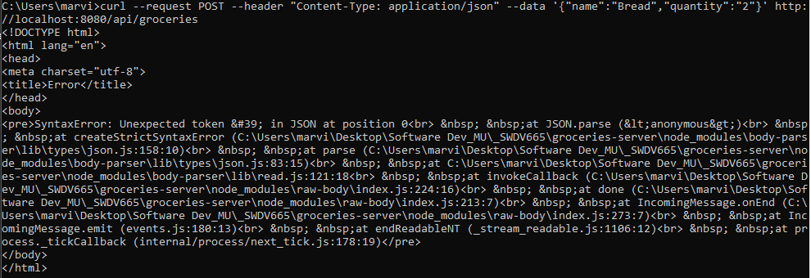

Research did provide various methods that could potentially solve the json parse issue I was encountering. To verify that communications were at least working between the application and my database, I try to post curl statements with no JSON data identified. Database records were created that only had ID and version attributes provide within no JSON data available. Navigating to <http://localhost:8080/api/groceries>, I was able to see the data sets created by the groceries server application. My issue, that I was not able to fix or completely identify dealt with the json parse function of the application. Unfortunately, I was not able to fully resolve issue and am currently still working on trying to get it to work. As a result, I am not able to create screencasts for this weeks Class Application additions. I have published a week 6 branch of the code for the database communication from the ionic Groceries app to the repository provided in my Submission. Within the “week-6” branch you will see the correctly compiled coding for the database communications, but as you can see from the capture in this folder, I was not able to get the application to work correctly.